**I2C SENSOR TRANSMITTER (SLAVE)**

**Introduction**

Transmitter is a device which sends data from one point to another using different techniques and protocols. Here it is designed for interfacing analog sensors with microcontrollers. The output signal from the analog sensor is transmitted to the microcontroller in digital form using I2C protocol. The transmitter first amplify the weak analog signal using op-amps and then implement the I2C protocol using a microcontroller to transmit the data.

***What is I2C ?***

*It is an acronym for inter-integrated circuit. It is a serial multi-master multi-slave communication protocol used to communicate between peripheral ICs (slave) and the processor (master) in a short distance. It is a 2 wire communication uses 2 signal wires known as SDA (data) and SCL (clock). The slave and master devices are connected parallel to the I2C bus and each device is identified using a 7 bit address (max. 128 devices).*

**Project Plan**

The I2C transmitter has 4 major parts; input sensor (analog), signal conditioner, analog to digital converter (ADC) and I2C interface. The input sensor is a readymade analog soil meter containing 3 sensors which are pH, moisture and light. The signal conditioner amplifies the sensor signal to a level which is required for the ADC. The ADC converts the analog signal to digital signal. The I2C interface establishes a communication with the master and sends the digital signal to the master.



**ADC**

**I2C**

**Interface**

**Signal Conditioner**

**Soil Meter**

**(pH, Moisture, Light)**

**Analog Sensor**

The below given image represents the choosen soil meter. It is an active sensor (no external power required) which is capable of measuring Light, Moisture and pH. It produces a small EMF for each measurements. pH and moisture measurement is done by using different electrodes. The EMF produced between the elctrodes is due to the ion flow in the soil through the electrodes. There are separate electrodes for each measurement. The amount of light is measured by using a solar cell. Then, the generated EMF is given to the moving coil meter through a sensor selection switch.

Observed Specifications

Moving coil resistance : 700Ω

Sensor output voltage range (with coil load) : 0-200 mV

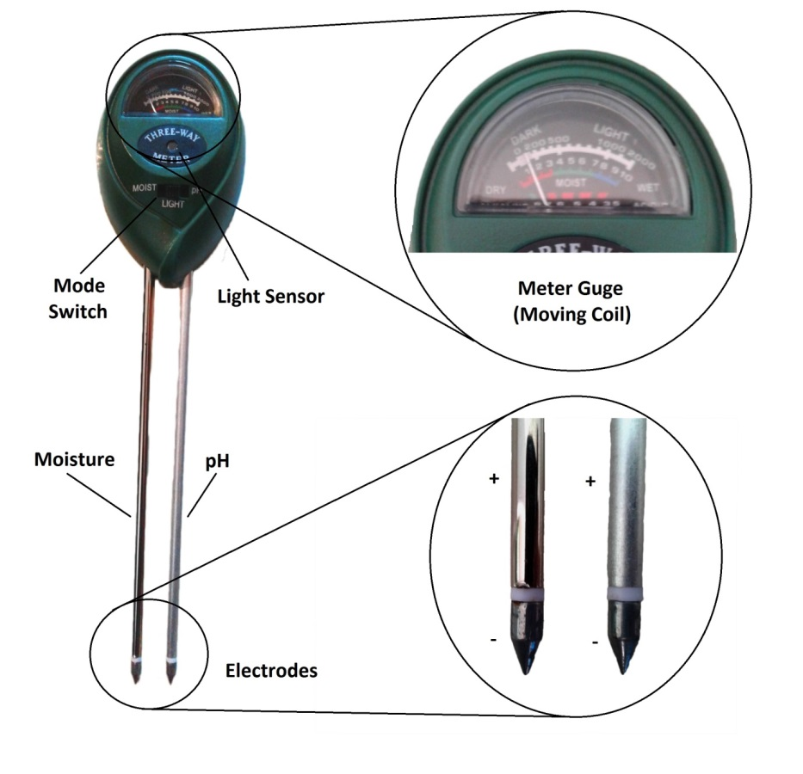

|  |  |
| --- | --- |
| **Meter Reading (Moisture)** | **Voltage (Across moving coil meter)** |
| 1 | 00 mV |
| 2 | 20 mV |
| 3 | 40 mV |
| 4 | 60 mV |
| 5 | 80 mV |
| 6 | 100 mV |
| 7 | 120 mV |
| 8 | 140 mV |
| 9 | 160 mV |
| 10 | 200 mV |

Table 1: Signal v/s Gauge reading

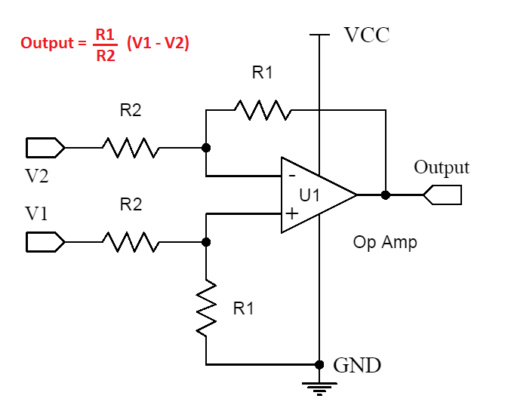**Signal Conditioner**

The purpose of signal conditioner is to convert the sensor signal (200 mV) to a value which is required for the ADC for analog to digital conversion. It is basically an op-amp amplifier circuit. Here, the input signal is a DC singnal, so a differential amplifier with a gain other than unity is used to amplify the 200 mV DC signal. It also helps to avoid the loading effect on the sensor. The given circuit is representing an ideal differential amplifier using op-amp.

Signal conditioner design

The power supply required for the signal conditioner is 5V DC (single power supply). Here CA3140 is used for this pupose, because it works well in low voltages. It gives an output voltage swing of 3.7V at 5V input power supply. Due to this limitation, The ADC input ia set at a maximum of 2.56 V. So the signal conditioner must provide a 2.5V output for the 200mV input.

Gain , $G=\frac{2.5}{0.2}$ = 12.5

First, fix the R1 with a 560KΩ resistance.

By using the differential amplifier equation,

$R2=\frac{560}{12.5}$ = 44.8 KΩ

The value of R2 is small compared to R1, therefore a small change in the value of R2 will cause a big change in the gain. This will introduce error in the measurement. Therefore, to reduce the variation in R2 value and increase the precision by choosing 3 resistors in parallel combination.

R2 = 100KΩ || 100KΩ || 560KΩ = 45.90 ≈ 44.8

The final circuit is given below.

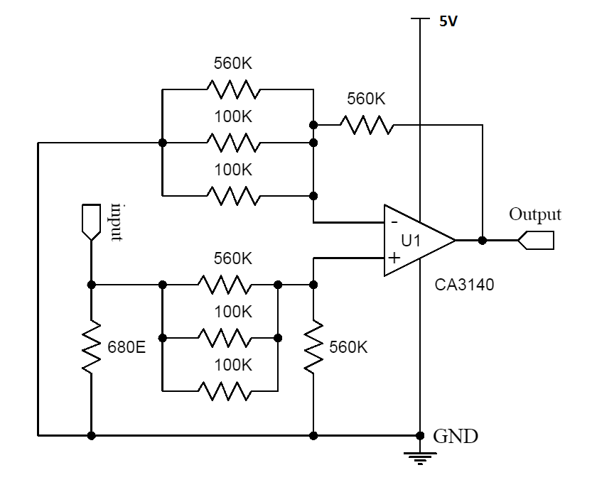

Here, inverting input (V2) is connected to the ground to eliminate the V2 term from the differential amplifier equation. So, now the V1 (input) is alone determines the output. The 680Ω resistor in the input is used as a dummy resitor for mimicing ‘moving coil meter’. Otherwise, the sensor output will change from 0-200mV range.

Observations

The observed input and output values and the corresponding gain is given in the below table.

@ Vcc = 5.55V

|  |  |  |
| --- | --- | --- |
| **Input** | **Output** | **Gain** |
| 4.0 mV | 0.062 V | 15.50 |
| 22.5 mV | 0.294 V | 13.00 |
| 40.8 mV | 0.524 V | 12.80 |
| 58.2 mV | 0.738 V | 12.65 |
| 70.7 mV | 0.896 V | 12.67 |
| 95.0 mV | 1.195 V | 12.57 |
| 115.6 mV | 1.460 V | 12.63 |
| 139.4 mV | 1.749 V | 12.55 |
| 167.3 mV | 2.080 V | 12.43 |
| 199.6 mV | 2.480 V | 12.43 |

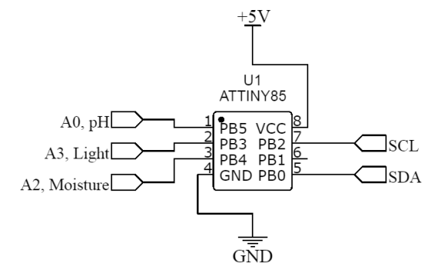**ADC and I2C Interface**

It is easy to implement the ADC and I2C communication using a microcontroller. Here, the circuit need only a low sampling rate ADC (because the signal is DC), So microcontroller ADC is very good for this purpose. The whole process only require some programing to complete these processes.

ATTiny85 is a small 8 pin microcontroller containing 4 inbuilt ADC and the I2C ports. So it is selected for this project. The 3 ADC inputs are used to connect to the 3 sensors.

**Full Circuit Diagram**

The below given circuit diagram represents the full system diagram.

Three copies of the above mentioned signal conditioner is provided for each input signal from the sensor. The negative connection from three of the sensors are connected to the GND to ensure that the input signal is in reference with the amplifier GND. The jumper in the pH sensor amplifier output is used at the event of microcontroller programing. Normally it is shorted and at the event of programing it should be in open position because, the pin 1 of the microcontroller is used for both reset and ADC functions. At normal condition it is fused as ADC, so it works as analog input (ADC) pin. But, for reprograming the microcontroller, it is importnt to apply a high voltage ( > vcc) in the reset pin (High voltage programing). If it is not opened at that programing time, there is a chance of damaging the op-amp and failure of the programing attempt. The I2C output port contain 4 pins. Two (SDA & SCL) for I2C communication and the other two is to provide the working voltage for the circuit. The ISP (in-system programing) is used for the programing of the microcontroller. The capacitors in the circuit is to reduce the noise in the powersupply and provide a stable voltage to the circuit.

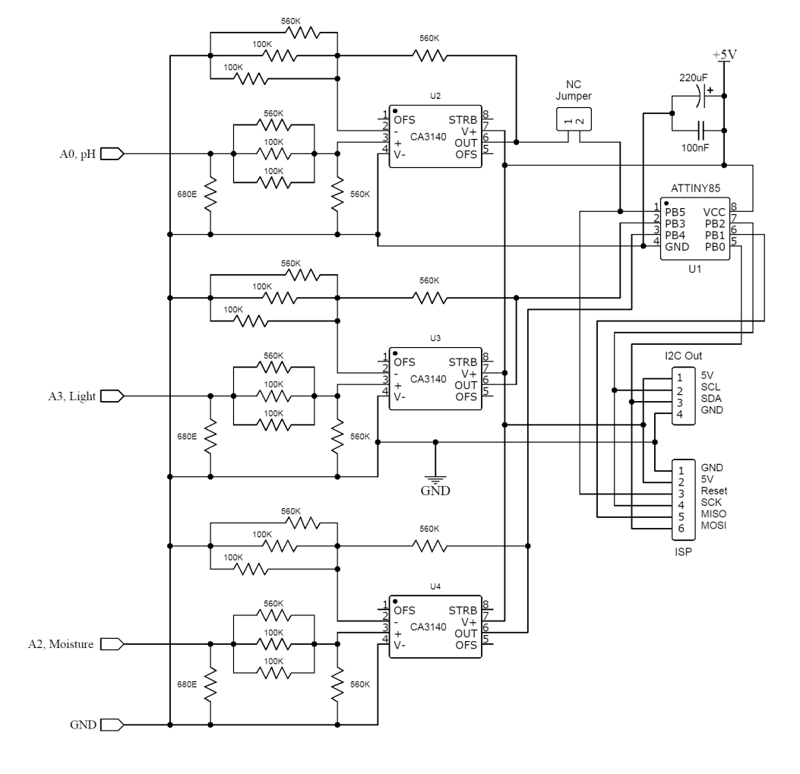

**The Prototye**

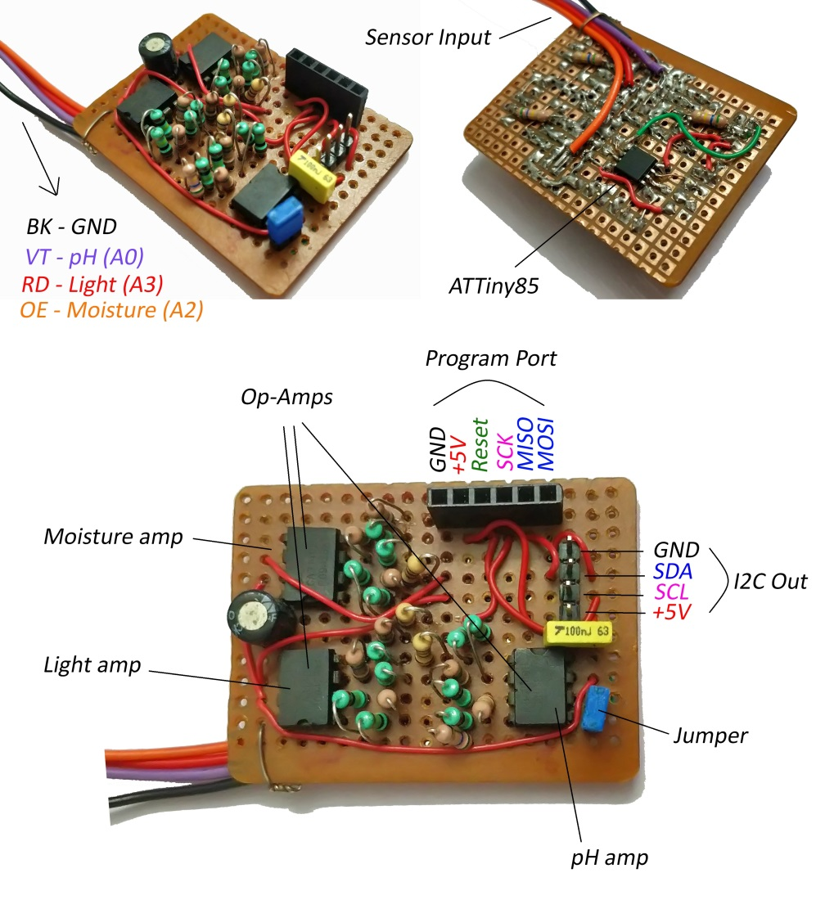

**Software (Language used: c++)**

The below given program is the one which is uploaded in the microcontroller. It works as a slave. The slave address is fixed in this program. For connecting multiple transmitters together , it is important to change the slave address for each device. In this program, the data from the ADC is directly send to the master device. The sending is only occurred when the master requests for data. The ADC in this ATtiny85 have 10 bit resolution. So the maximum value get from the ADC is 1023 (210-1). The rference voltage for the ADC is set internally to a 2.56V in the program.

Program Flow

* Including necessary library files
* Initializing the variables
* Initializing object for I2C
* Waiting for master request
* If master requests, read 3 ADC values
* Send the measured values to the master
* Again waiting for another master request

Program

#include <TinyWire.h>

int16_t ph ; int16_t moisture; int16_t light; //variables for saving data

void setup() {

analogReference(INTERNAL2V56);

TinyWire.begin(1); // join i2c bus with address #1

TinyWire.onRequest(requestEvent); // register event

}

void loop() {

delay(100);

}

void requestEvent() { // function that executes whenever data is requested by master

// this function is registered as an event, see setup()

ph = analogRead(A0);

moisture = analogRead(A3);

light = analogRead(A2);

byte myArray1[2];

byte myArray2[2];

byte myArray3[2];

myArray1[0] = (ph >> 8) & 0xFF;

myArray1[1] = ph & 0xFF;

TinyWire.send(myArray1, 2);

myArray2[0] = (moisture >> 8) & 0xFF;

myArray2[1] = moisture & 0xFF;

TinyWire.send(myArray2, 2);

myArray3[0] = (light >> 8) & 0xFF;

myArray3[1] = light & 0xFF;

TinyWire.send(myArray3, 2);

}

Observations

Data that are received in the PC serial monitor.

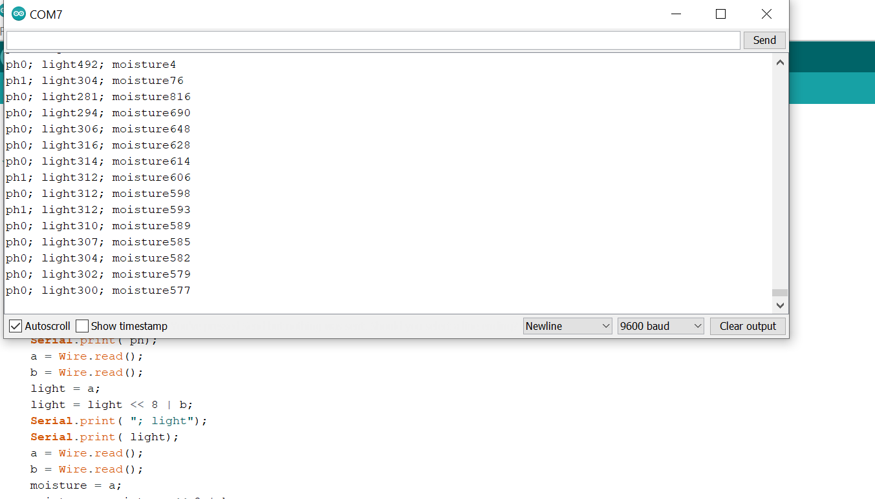

**Finished Ptotype**

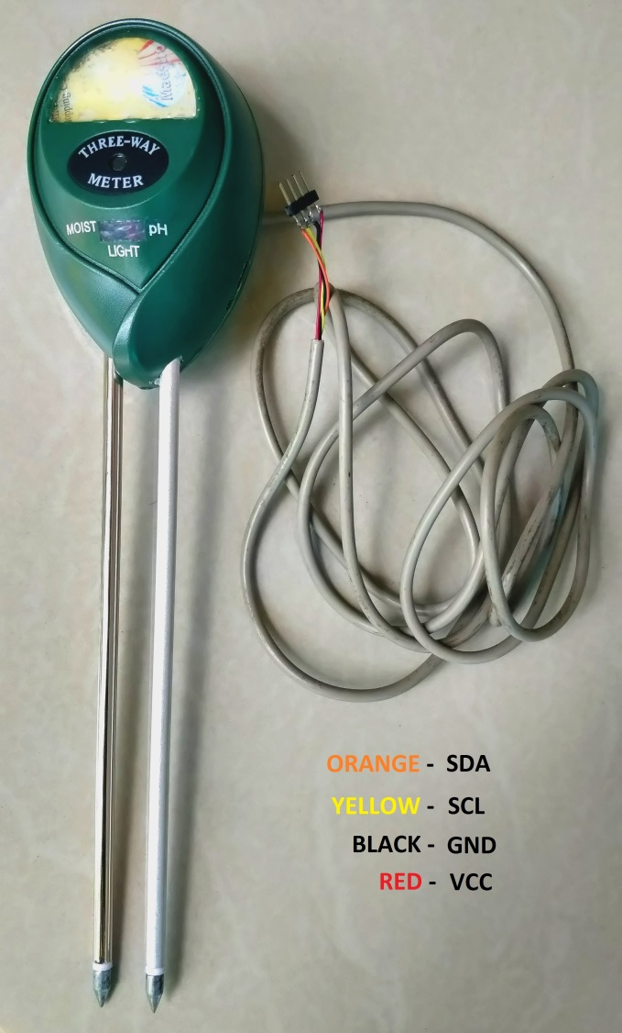

**Achieved Outcomes**

* Successfully transmitted data via I2C bus
* Capable of connectimg 128 slave devices (transmitters) parallely to the I2C bus
* Enclosed the PCB in a small enclosure

**Future work**

Migration of communication protocol

Here, the communication protocl used is I2C. The problem with the protocol is that , it is works only in a short distance (few meters). For sensor networking in a large area, it is important to use a long distance protocol. So in the future development faces the protocol should be changed .

Wireless tansmission

The migration from wire communication to wireless communication should reduce the complexity and cost by avoiding the wiring.

*Yadukrishnan K M*